1. There is now branch assignment when creating or editing users (users are assigned to both Main and Yshop by default).

**Note:** Users can view orders and customers only on his/her assigned branches (purchases and suppliers are still visible to all users).

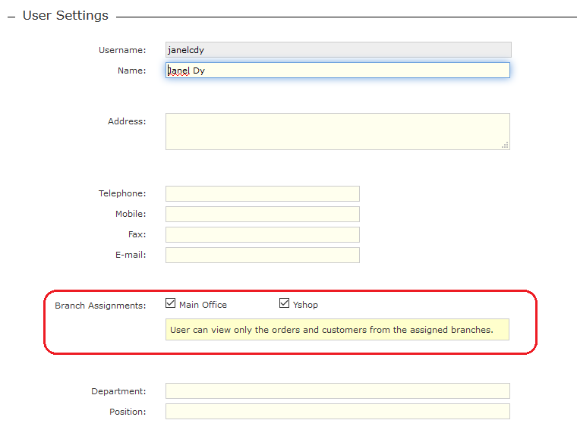

1. There is now branch assignment when adding or editing customers (customers are assigned to Main by default).

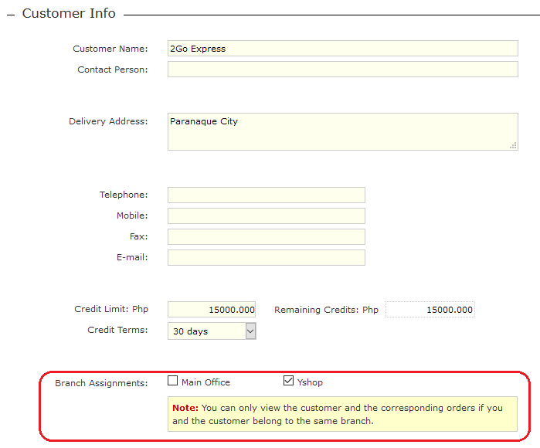

1. Only the customers and orders from the assigned branches of user are visible.

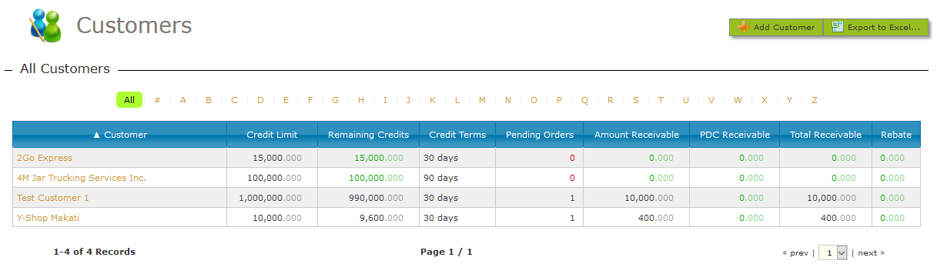

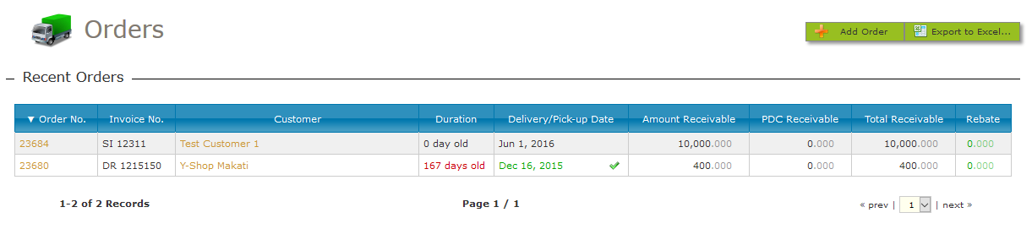

1. An error message is displayed if the user attempts to view a customer or order from another branch (ex. by manually typing the URL in Firefox).

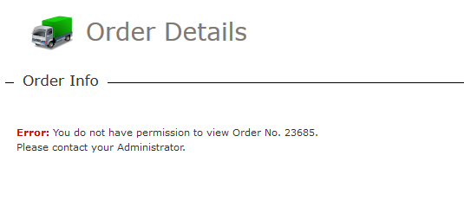

1. When viewing orders from inventory, only the orders from the assigned branches will be visible.

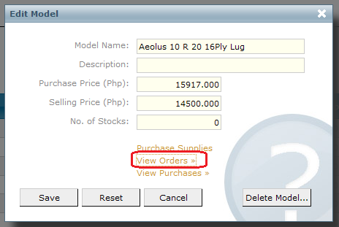

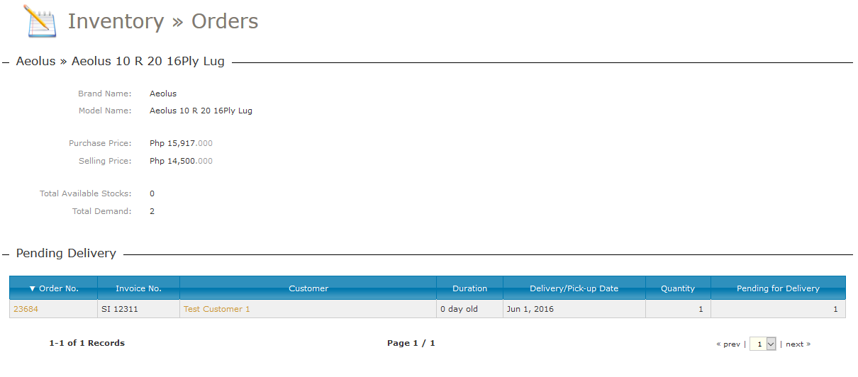

1. Only the orders and customers from assigned branches will be visible in search results.

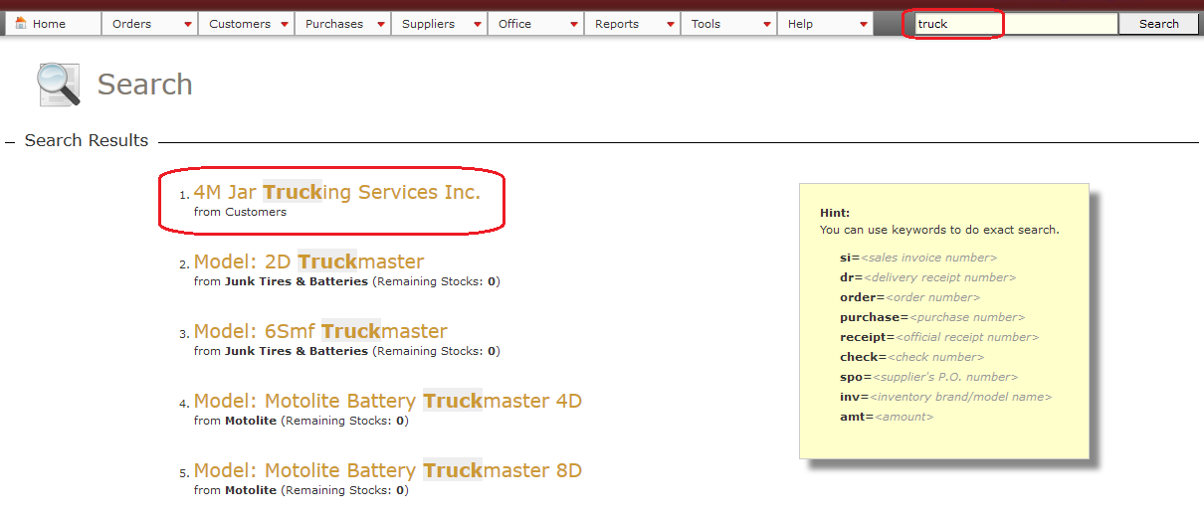

1. Fixed several bugs (see Bug Tracker page for complete list).
2. If you want to manually add/edit/remove branches, for the meantime go to <http://localhost/phpmyadmin> > ios > Tables > branch and click Insert (to add) or Edit (to modify). Note: id should be unique.

